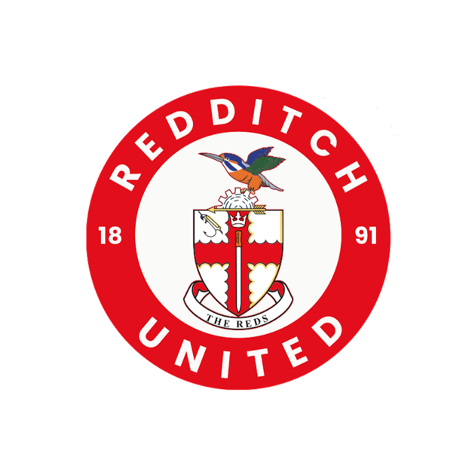
RORY BUDGE
Whistle Blowing Policy

Implementation Date: | 29/09/26
Agreed By: | RORY BUDGE
Next Review Date: | 29/09/27

Purpose:
REDDITCH UNITED is committed to conducting all business in a professional and ethical way and we expect all staff and volunteers to maintain the same high standards. The club is committed to developing a culture where it is safe and acceptable for all involved in activities across the club to raise concerns about any unacceptable practice, behaviour, wrongdoing or misconduct. The purpose of this policy is to make clear that club staff can whistle blow without fear of victimisation, subsequent discrimination or disadvantage. This Whistleblowing policy is intended to encourage and enable everyone to raise serious concerns directly to the club. We do not want staff to overlook a problem or seek a resolution outside of the club without first bringing the matter to our attention.
Statement:
REDDITCH UNITED understands that occasionally things go wrong, if they do go wrong then we ask you to tell us. Whistleblowing concerns misconduct, illegal or underhand practices by individuals and, an organisation; and in as far as safeguarding goes- about the way care and support is being provided, such as practices that cause harm, or the risk of harm to others, or are abusive, discriminatory or exploitative.
What is Whistle Blowing: Whistle Blowing in a safeguarding context means revealing and raising concerns over misconduct or malpractice within an organisation, or with an independent structure associated with it.
It can be used as an early warning system or when it’s recognised that appropriate actions have not been taken. This approach or policy is adopted in many different walks of life.
Any adult or young person with concerns about colleagues conduct towards a child, young person or adult at risk can also use whistle blowing by contacting the people and organisation as listed below.
The law provides protection for those who raise legitimate concerns about specified matters, known as qualifying disclosures. A qualifying disclosure is one made in the public interest if an employee has a reasonable belief that one of the following has taken place:
- fraud and/or money laundering.
- a bribe, offered or received.
- a criminal offence.
- a miscarriage of justice.
- an act creating risk to health and safety.
- an act causing damage to the environment.
- breach of any laws, regulations, other legal obligations or The FA Group's policies or procedures; or
- other serious risk that threatens clients, colleagues, the public, the environment, or The FA Group's reputation; and
- concealment of any of the above; is being, has been, or is likely to be committed. It is not necessary for you to have proof that such an act is being, has been, or is likely to be, committed - a reasonable belief is sufficient. Please be aware that you have no responsibility for investigating the matter as it is The FA Group's responsibility to ensure that an investigation takes place.

If you have reported a safeguarding concern about a child or an adult at risk and feel that it has not been dealt with correctly. Then there are a number of organisations you can and should escalate your concern to. This the same if you wish to raise a concern around the behaviour or actions of someone which could lead to potential repercussions against you within you club environment. This whistleblowing policy affords you the chance to get the correct outcome without the risk of it coming back on you from within the club.

Reporting a concern, useful contacts:
Club Welfare Officer: DAN SEWELL National League DSO: Martyn Cannon
Email Address: welfare@redditchunited.co.uk Contact number: 07842 429798
Email: Safeguarding@thenationalleague.org.uk

